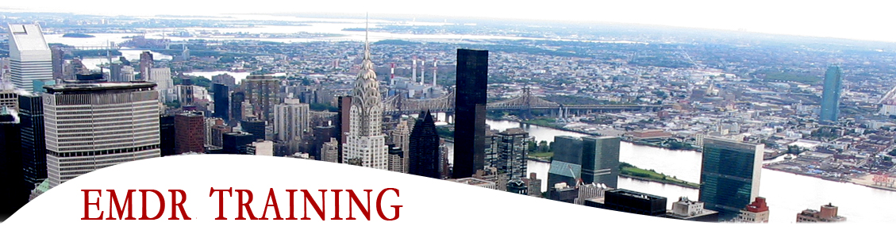

REGISTRATION FORM

(Please Print)

Name of Workshop: _______________________________________

Date(s): _______________________________________________

Your Name: ____________________________________________

Profession: ________________________ Degree: ______________

License/Registration Number: ________________________________

Bus. Address: ___________________________________________

City/State/Zip: __________________________________________

Work Number: __________________________________________

e-mail: ________________________________________________

How did you find out about us? ______________________________

Please make check payable and send to:

William M. Zangwill, Ph.D.
EMDRIA Approved Trainer
124 W. 93rd St. #9F
NY, NY 10025

For additional information, please contact me at the address above, by email, William@DrZangwill.com, or phone (212) 663-2989.

